Part 1: Navigation Bar with Routing
Aim:
To implement a navigation bar in ReactJS that allows smooth routing between pages such as Home, Courses, Categories, Cart, Checkout, and Profile in a web-based online course marketplace using React Router.

Theory:
In modern web development, applications are often built as Single Page Applications (SPAs), where navigation between pages occurs without reloading the entire page. ReactJS, combined with React Router, provides an efficient way to create such dynamic and responsive SPAs. In this project, we apply these concepts to build an online course marketplace where users can seamlessly browse courses, view details, add them to a cart, and proceed to checkout — all within a single-page structure.
Role of React Router in the Application:
React Router is a powerful routing library that enables navigation and dynamic rendering of components within React applications. Instead of sending a new request to the server every time a user switches pages, React Router manages navigation entirely on the client-side. This means that transitions between pages (like from Home to Courses or Cart to Checkout) happen instantly, providing a fast, app-like experience — essential for modern e-learning platforms.
In this marketplace application, each main section — Home, Courses, Categories, Cart, Checkout, and Profile — is treated as a separate route. The Navigation Bar (Navbar) acts as the central hub, allowing users to move effortlessly between these pages without page reloads.

Core Concepts and Components:
React Router provides several key components that make this functionality possible:
- <BrowserRouter>
This component wraps the entire application and enables the use of the HTML5 History API, which keeps the user interface in sync with the browser URL. It ensures that navigation updates the address bar and allows users to use the browser’s back/forward buttons seamlessly.
- <Routes> and <Route>
These define the various paths (URLs) and specify which component should render for each path. For instance,
  - The path / might render the Home component.
  - The path /courses might render a CoursesList component showing available courses.
  - The path /cart would display items users plan to purchase.
This modular approach helps maintain clean, well-organized code.
- <Link> and <NavLink>
These components replace traditional HTML <a> tags. They allow smooth transitions between routes without reloading the page.
  - <Link> is used for general navigation.
  - <NavLink> is ideal for navigation bars since it can apply special styles (like highlighting the active tab) to indicate which page the user is currently viewing.

Importance of the Navigation Bar (Navbar):
The Navigation Bar is one of the most essential elements in any web-based platform, particularly for an e-learning marketplace. It provides users with easy access to major sections such as Home, Courses, Categories, Cart, and Profile.
A well-designed Navbar:
- Stays consistent across all pages, offering a uniform and intuitive experience.
- Often remains fixed at the top, allowing quick access even while scrolling through long lists of courses.
- Enhances the site’s professional look and usability.
In this project, the Navbar ensures users can explore courses, manage their cart, and check their profile efficiently — all without interrupting the flow of learning or shopping.

Advantages of Using React Router for the Course Marketplace:
- Seamless User Experience:
Navigation feels instant and interactive — crucial for retaining users on learning platforms.
- Preserved Application State:
Data such as selected courses, user login information, and cart items remain intact while navigating between pages.
- Dynamic and Conditional Routing:
Routes can adapt based on user actions or roles (for example, showing extra options for instructors).
- Improved Performance:
Since only components are re-rendered instead of full pages, performance remains smooth even with multiple navigations.
- Cleaner and Organized Code Structure:
Routes and their components are neatly defined, making the project easier to maintain and scale.

Conclusion:
In the context of an online course marketplace, implementing routing using React Router enhances the interactivity, speed, and user engagement of the platform. The Navbar provides a centralized way to explore different sections — from discovering new courses to checking out purchased ones — all while maintaining a smooth, uninterrupted user experience.
By combining ReactJS and React Router, developers can build modern, scalable, and responsive e-learning platforms that mimic the professional experience of established platforms like Udemy, Coursera, and Skillshare.

Code:
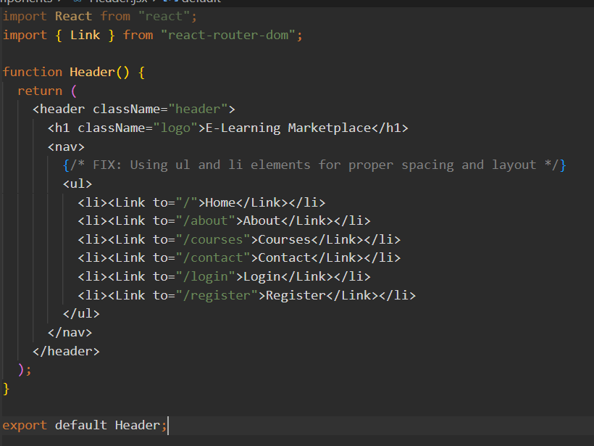


Output Preview:
A purple navigation bar with white text links for Home, Courses, Categories, Cart, Login, and Contact. Clicking on any of these links updates the displayed page instantly without reloading the entire site.

Conclusion:
In this module, we learned how to implement React Router to enable smooth and efficient navigation within a web-based online course marketplace. The Navigation Bar allows users to access key sections such as Home, Courses, Categories, Cart, Checkout, and Profile instantly, without any page reloads.
This enhances the user experience by ensuring that data such as selected courses or cart items remain preserved during navigation. The consistent and responsive Navbar design improves both usability and visual appeal, creating a modern, app-like interface.

Part 2 – Home Page
Aim:
To design and develop a visually appealing, interactive, and responsive Home Page for a Web-Based Online Course Marketplace built using ReactJS. The Home Page should act as the central hub where users can explore featured courses, browse categories, and access key sections like Courses, Cart, and Profile. The design aims to create a smooth and engaging learning experience that mimics professional platforms such as Udemy, Skillshare, or Coursera.

Theory:
The Home Page is the most important and user-facing component of any web-based platform. In the context of an Online Course Marketplace, the home page serves as the primary entry point for learners, providing an overview of the platform’s offerings — including trending courses, featured instructors, and category-based browsing options. It aims to welcome users, convey trust, and guide them naturally toward discovering new learning opportunities.
Built using ReactJS functional components, the Home Page integrates interactivity, modularity, and responsiveness, forming the foundation of a dynamic e-learning environment. The Navigation Bar, implemented as a reusable React component, allows seamless movement between major sections such as Home, Courses, Categories, Cart, and Profile. This navigation is powered by React Router DOM, which ensures smooth page transitions without browser reloads — maintaining the Single Page Application (SPA) experience.
The hero section of the Home Page features an inviting welcome message like “Learn Anytime, Anywhere” or “Empower Your Skills with Our Courses.” It typically includes a background image or gradient design along with action buttons such as “Browse Courses” and “Get Started” to encourage user engagement. Using CSS Flexbox or Grid layout, the hero section is designed to align content symmetrically while remaining fully responsive across various devices and screen sizes.
Beneath the hero section lies the Featured Courses area, showcasing popular or trending courses in a card-based layout. Each course card displays essential information such as the course image, title, instructor, price, and rating. These cards are built using reusable React components, making it easy to dynamically render data from an API or JSON file. Hover effects and subtle animations can enhance interactivity and visual appeal, creating a professional, marketplace-like experience.
The Categories section allows users to browse courses by domain (e.g., Programming, Design, Marketing, Business, or Data Science). This feature-oriented organization helps users navigate quickly to their interests. Each category is represented through icons or thumbnails, implemented using React components and styled for responsiveness.
A Statistics or Achievements section (e.g., 10K+ Enrolled Students, 500+ Expert Instructors, 1000+ Available Courses) adds credibility and builds user trust. These visual statistics demonstrate the platform’s growth and impact, motivating new users to register. The content in this section can be static initially and later updated dynamically from the backend database.
The Footer section at the bottom of the page (e.g., © 2025 LearnHub | Made by (Chanakshi) adds a sense of professionalism and completion. It includes navigation shortcuts, contact details, and links to policies or social media handles. The footer design emphasizes simplicity and accessibility through clear typography and consistent color contrast.
From a technical perspective, the Home Page leverages React’s component-based architecture, dividing the layout into independent, reusable components such as Navbar, Hero, FeaturedCourses, Categories, Stats, and Footer. This modular structure simplifies maintenance and future scalability — for example, adding new sections like Student Testimonials or Instructor Highlights without affecting existing code.
Interactivity can be managed using React Hooks like useState and useEffect, handling dynamic updates such as featured course rotation or responsive behavior upon window resizing. Additionally, responsive web design principles are followed to ensure optimal display on all devices:
- Mobile-first approach for adaptive layouts.
- Fluid grids and media queries for dynamic resizing.
- Accessible color schemes and typography for readability.
- Lightweight assets and optimized images for faster loading.
The Home Page operates within a Single Page Application (SPA) structure powered by React Router DOM. Instead of reloading pages during navigation, React renders new components instantly within the same view. This ensures smooth transitions and quick interactions, providing users with a fast, app-like experience.
Example routes may include /home, /courses, /categories, /cart, and /profile. Each of these routes corresponds to a dedicated React component that dynamically updates the visible content while maintaining the application’s state.
Such SPA-based architecture offers several benefits:
- Faster performance due to component-based rendering.
- Reduced network usage through efficient resource handling.
- Improved user engagement via fluid and uninterrupted navigation.
Overall, the Home Page of the Online Course Marketplace effectively combines educational accessibility with modern web design aesthetics. It acts as a gateway to the platform, ensuring users feel guided, inspired, and encouraged to explore courses — all while maintaining technical performance and visual harmony.

Conclusion:
In this module, we learned how to design and implement a responsive and interactive Home Page for a ReactJS-based Online Course Marketplace. The page serves as the digital front door of the application, welcoming users with engaging visuals, clear navigation, and well-organized sections like Featured Courses, Categories, and Statistics.
Using React components and React Router DOM, we achieved a smooth, single-page navigation experience that allows users to browse and interact without page reloads. Responsive design techniques ensure that the layout adapts gracefully across devices, offering a consistent and professional interface.
This implementation successfully demonstrates how a well-structured and aesthetically pleasing Home Page enhances user engagement, accessibility, and trust, setting the foundation for an intuitive e-learning environment that mirrors industry-standard platforms such as Udemy, Coursera, and Skillshare.

Code:
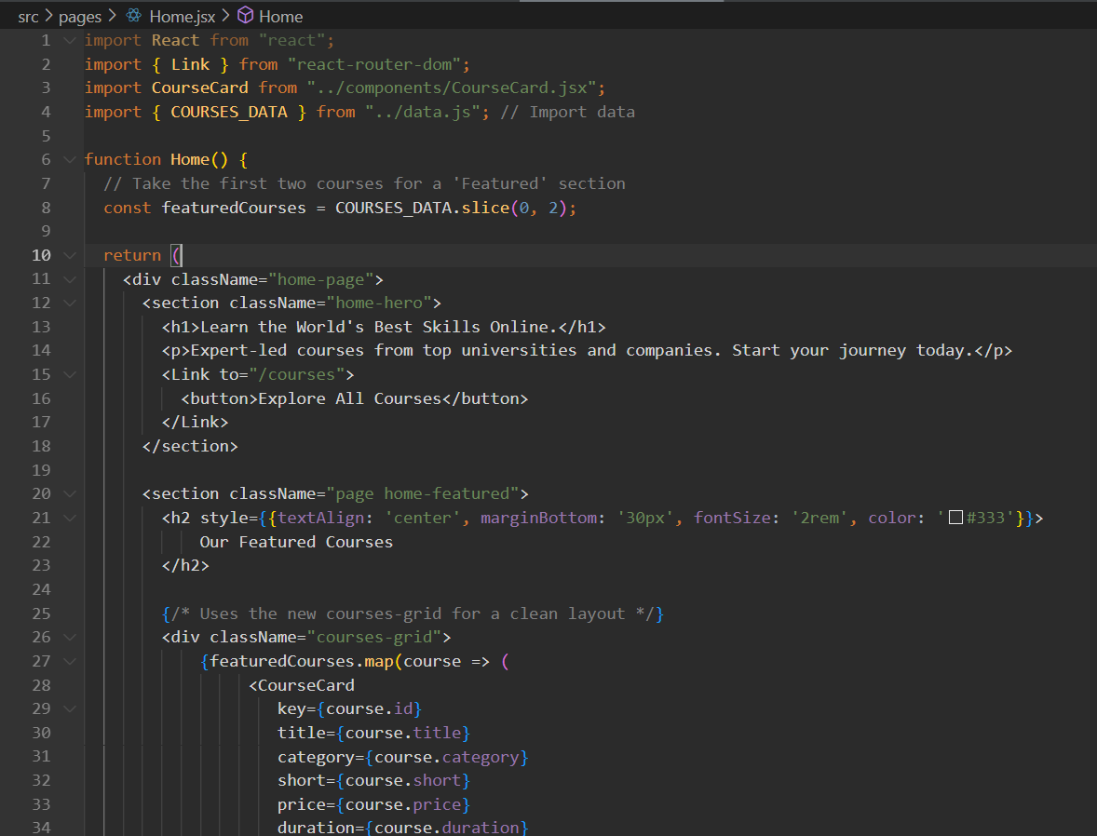
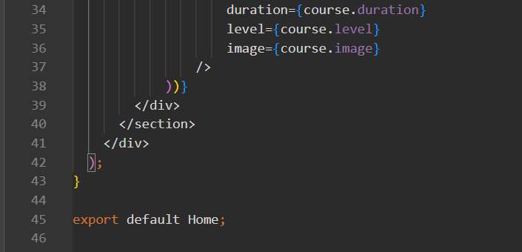
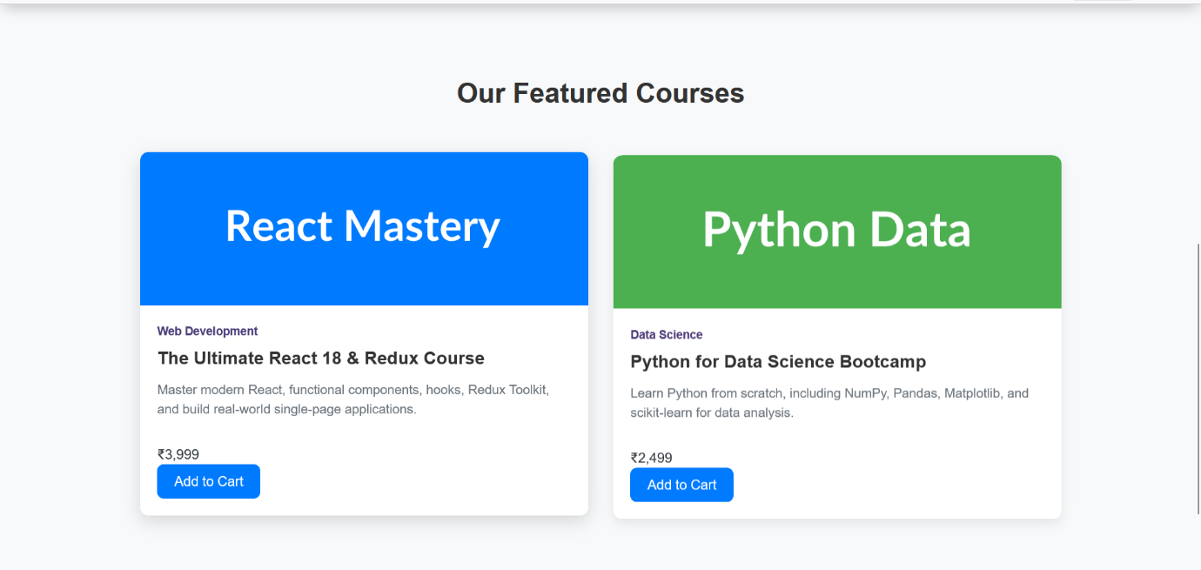

Part 3 – Product Listing Page (Course List & Details Display)
Aim:
To design and implement a Course Listing Page in the Online Course Marketplace web application that displays a collection of available courses with essential details such as course name, category, instructor, duration, price, and description. The page should allow users to browse, view course information, and interact dynamically with the data using ReactJS state and props.

Theory:
In the modern e-learning ecosystem, digital platforms play a vital role in organizing and delivering educational content efficiently. Among various modules of an online learning platform, the Product Listing Page (PLP) — referred to here as the Course Listing Page — is one of the most important components. It serves as the main interface where learners can explore all available courses offered on the platform.
In this Online Course Marketplace, the Course Listing Page acts as the central repository displaying a structured and accessible catalog of courses. It provides users with key information such as course title, instructor, category, price, and learning objectives, enabling them to make informed decisions before enrolling.
The main purpose of this module is to ensure that the course data is informative, visually organized, and interactive. The design of this page aims to help users identify suitable courses by topic or skill level, fostering a smooth and enjoyable browsing experience — similar to professional platforms like Udemy, Coursera, or Skillshare.

Technical Overview:
The Course Listing Page is developed using ReactJS, a powerful JavaScript library widely used for building responsive, component-driven web applications. React’s component-based architecture allows for modular, reusable, and easily maintainable UI design — ideal for rendering a large number of course cards dynamically.
React’s .map() function plays a crucial role in this module. Instead of creating static HTML elements for each course, React enables dynamic rendering where data (such as course details) can be iterated and displayed automatically. This approach ensures scalability — if the number of courses increases from 10 to 1,000, the page structure and performance remain efficient.

Key Attributes Displayed on the Course Listing Page:
Each course entry typically includes the following information:
- Course Name – The title of the course (e.g., “React for Beginners”).
- Category – The subject area (e.g., Web Development, Design, Marketing).
- Instructor Name – The tutor or mentor offering the course.
- Course Duration – Time required to complete the course (e.g., 8 hours, 5 modules).
- Price or Access Type – Indicates whether the course is free or paid.
- Description – A short summary of what the learner can expect.
- Enroll/Add to Cart Button – Allows the user to enroll or add the course to their shopping cart for purchase.
These details can be presented in card layouts using reusable components such as CourseCard, making the UI modular and easy to update or expand. For example, each CourseCard may include an image, course title, brief description, and interactive buttons.

Design and User Interface Considerations:
From a UI/UX perspective, the Course Listing Page focuses on clarity, visual hierarchy, and consistency. The design uses a clean and professional color palette — for example, purple for brand identity, white for background, and subtle gray tones for contrast.
Each course is displayed in a responsive grid layout, ensuring equal spacing and visual balance. When hovered over, cards may scale slightly or show additional details, improving interactivity and engagement.
For responsiveness, CSS Flexbox and media queries are used to adjust the number of course cards displayed per row based on the screen size — for instance, four cards per row on desktops, two on tablets, and one on mobile devices.
This ensures an optimal browsing experience on all platforms, from large desktop screens to smaller smartphones.

Component Reusability and Data Management:
React promotes reusability and data-driven rendering, making it ideal for managing multiple courses efficiently. The CourseList component can receive an array of course objects through props and render a list of CourseCard components dynamically.
Additionally, the course data can be stored locally (using arrays or local storage) or fetched from an external API. By utilizing React state and props, any update — such as adding a course to the cart or viewing details — instantly reflects in the UI without refreshing the page.
This reactivity creates a smooth and modern user experience while maintaining high performance.

Practical Applications and Future Enhancements:
The Course Listing Page goes beyond being just a static catalog. It acts as an interactive gateway for learners to explore and select courses. In future enhancements, this module can be extended with:
- Filters and Sorting: Filter by category, price, or difficulty level.
- Search Functionality: Allow users to quickly find specific courses.
- Pagination or Lazy Loading: Improve performance for large datasets.
- Dynamic API Integration: Load courses from a backend database.
- Course Details Page: Redirect to an individual course’s detailed information.
These features ensure scalability and alignment with real-world e-learning platforms.

Visual Identity and Professional Design:
The Online Course Marketplace maintains a visually consistent identity using its chosen color scheme (e.g., purple and white), typography, and iconography. Shadowed course cards, smooth transitions, and consistent spacing create a modern and professional interface.
The design not only attracts users visually but also improves usability and navigation, encouraging longer browsing sessions and higher engagement rates.

Conclusion:
In this module, we developed the Course Listing Page, a vital component of the Online Course Marketplace. The page serves as the platform’s educational catalog, displaying available courses dynamically using ReactJS components, state, and props.
By leveraging React’s component-based structure and dynamic rendering with .map(), the page achieves reusability, scalability, and responsiveness. Each course card presents key information clearly, helping users make informed learning decisions.
The design emphasizes both functionality and visual appeal, ensuring smooth user interaction, quick data updates, and professional presentation. This implementation demonstrates how ReactJS can efficiently manage and render large datasets, forming the foundation for a complete, interactive, and scalable e-learning platform similar to Udemy, Skillshare, or Coursera.

Code:
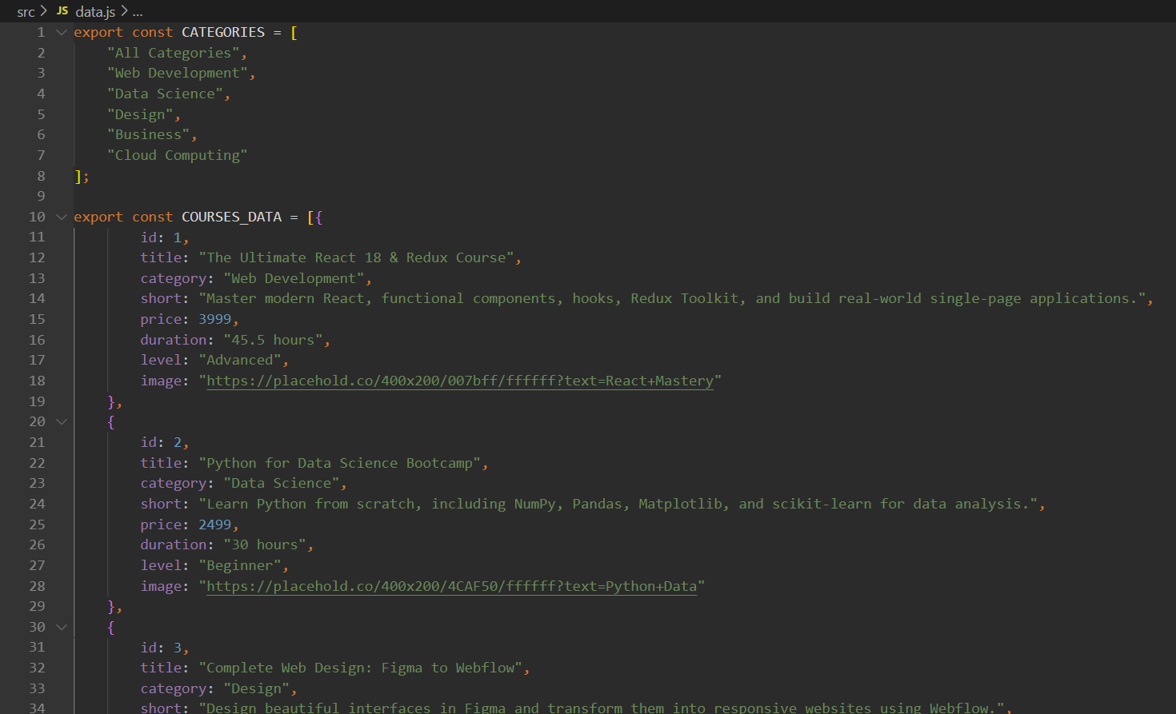
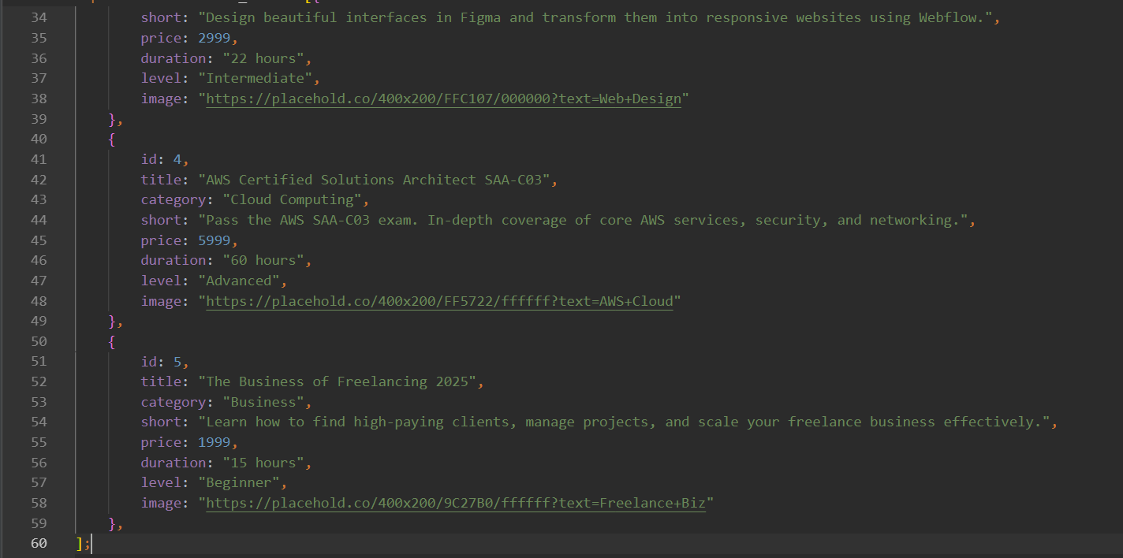
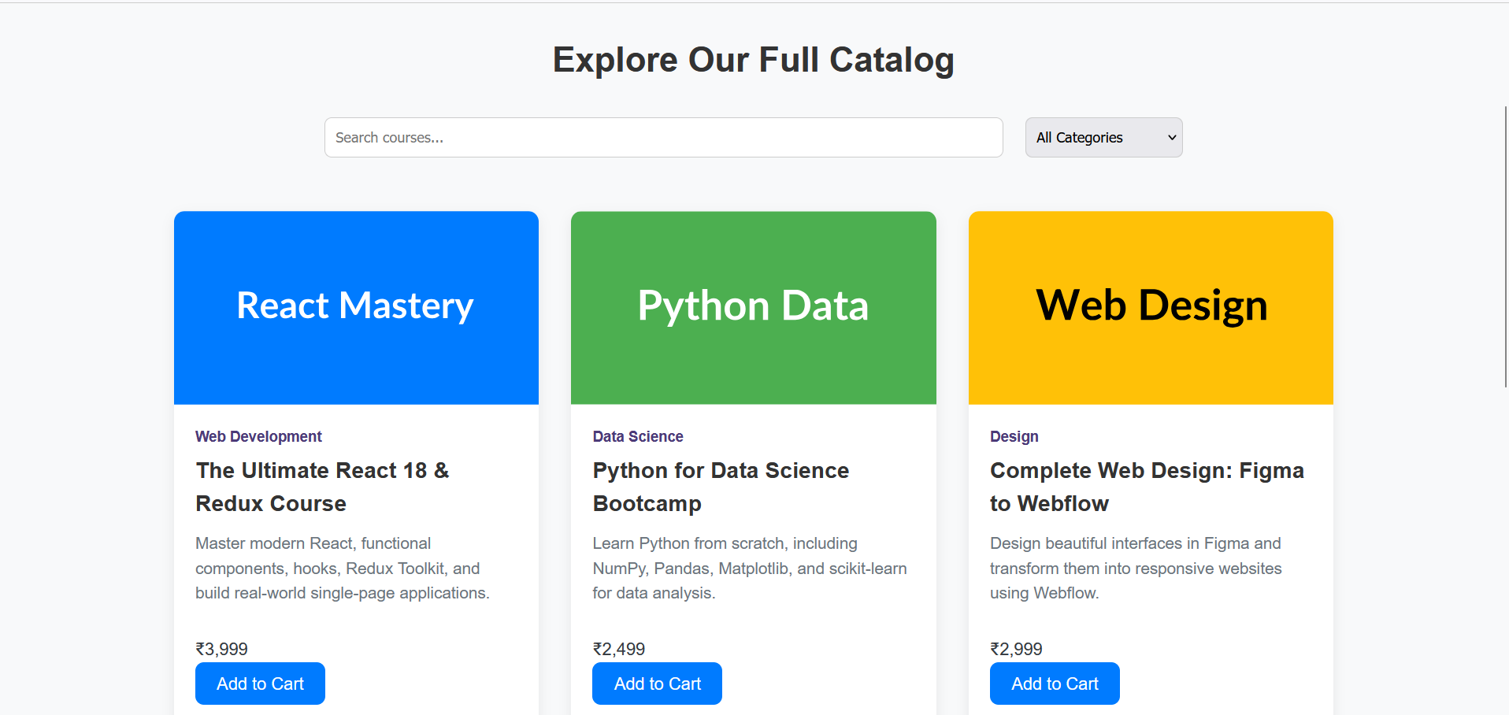

Part 4 – Course Reminder & Progress Tracker Page
Aim:
To develop a Course Reminder and Progress Tracker Page in the Language Learning Website that allows learners to schedule their study sessions, set learning reminders, and track their daily progress in completing lessons or activities. The objective is to implement smart learning management using ReactJS state, local storage, and event-driven interactions for an efficient and engaging e-learning experience.

Theory:
The Course Reminder and Progress Tracker is a key component of the Language Learning Website, designed to enhance the learner’s consistency and engagement. In online education, one of the biggest challenges is maintaining regular learning habits. Learners often forget to practice or skip lessons, which affects their overall progress and fluency.
This module aims to overcome that challenge by introducing a digital reminder and tracking system — helping users stay consistent, motivated, and aware of their learning journey.
Within the website, this feature allows users to:
- Add daily or weekly study reminders
- Record completed lessons
- Track their progress status (Pending / Completed)
- Monitor their learning streaks and milestones
Each tracker entry typically includes:
• Course or Lesson Name
• Study Duration (e.g., 30 mins / 1 hour)
• Reminder Time / Day
• Frequency (Daily / Weekly)
• Status (Pending / Completed)
Using ReactJS, this functionality becomes fully dynamic and responsive. The useState hook manages the current state of reminders — storing user inputs, updating progress, and reflecting it instantly on the page. Whenever a learner adds a new reminder or marks a task as completed, React automatically re-renders the UI to display the latest progress.
The useEffect hook is used to synchronize data with localStorage, ensuring that reminders and progress records persist even after the user refreshes or reopens the browser. This gives the feeling of a lightweight learning management system (LMS) without the need for a backend database — ideal for academic or small-scale web projects.
Interactive features such as “Mark as Completed” buttons or progress bars can be added to visually represent learner achievements. When a user marks a lesson as completed, the status updates instantly with color changes (e.g., green for completed, purple for pending). Such visual cues motivate learners and make tracking more intuitive.
From a UI/UX design perspective, the page should maintain clarity and focus. Using the website’s signature color theme (e.g., purple, white, and black) ensures consistency and visual appeal. Cards or tables can be used to display reminders neatly, with clear typography and simple icons for completion status.
This module not only strengthens the learner’s accountability but also introduces a habit-building system — encouraging regular practice and self-discipline. It demonstrates how ReactJS hooks like useState and useEffect can be combined with event handling to create real-time, data-persistent web interfaces.
In future enhancements, browser notifications or progress analytics could be added to further support personalized learning. However, even in its current form, the Reminder & Progress Tracker provides a perfect balance between simplicity and functionality, showcasing core frontend development concepts while addressing real learner needs.

Conclusion:
The Course Reminder & Progress Tracker Page effectively shows how ReactJS can be used to handle user data, manage state changes, and maintain persistent storage — all within the browser environment. This component transforms a simple form into a practical educational tool that promotes regular study habits.
It demonstrates full CRUD functionality (Create, Read, Update, Delete) using only frontend technologies, and ensures smooth user interaction without reloading the page.
From a learner’s point of view, this module makes the language learning process more structured and goal-oriented.
From a developer’s perspective, it enhances understanding of React hooks, localStorage integration, conditional rendering, and component-based UI design.
Overall, the Course Reminder & Progress Tracker page enriches the learning experience by combining technology with motivation — helping users stay consistent in their language learning journey and making the website more interactive, purposeful, and user-centered.
Code:
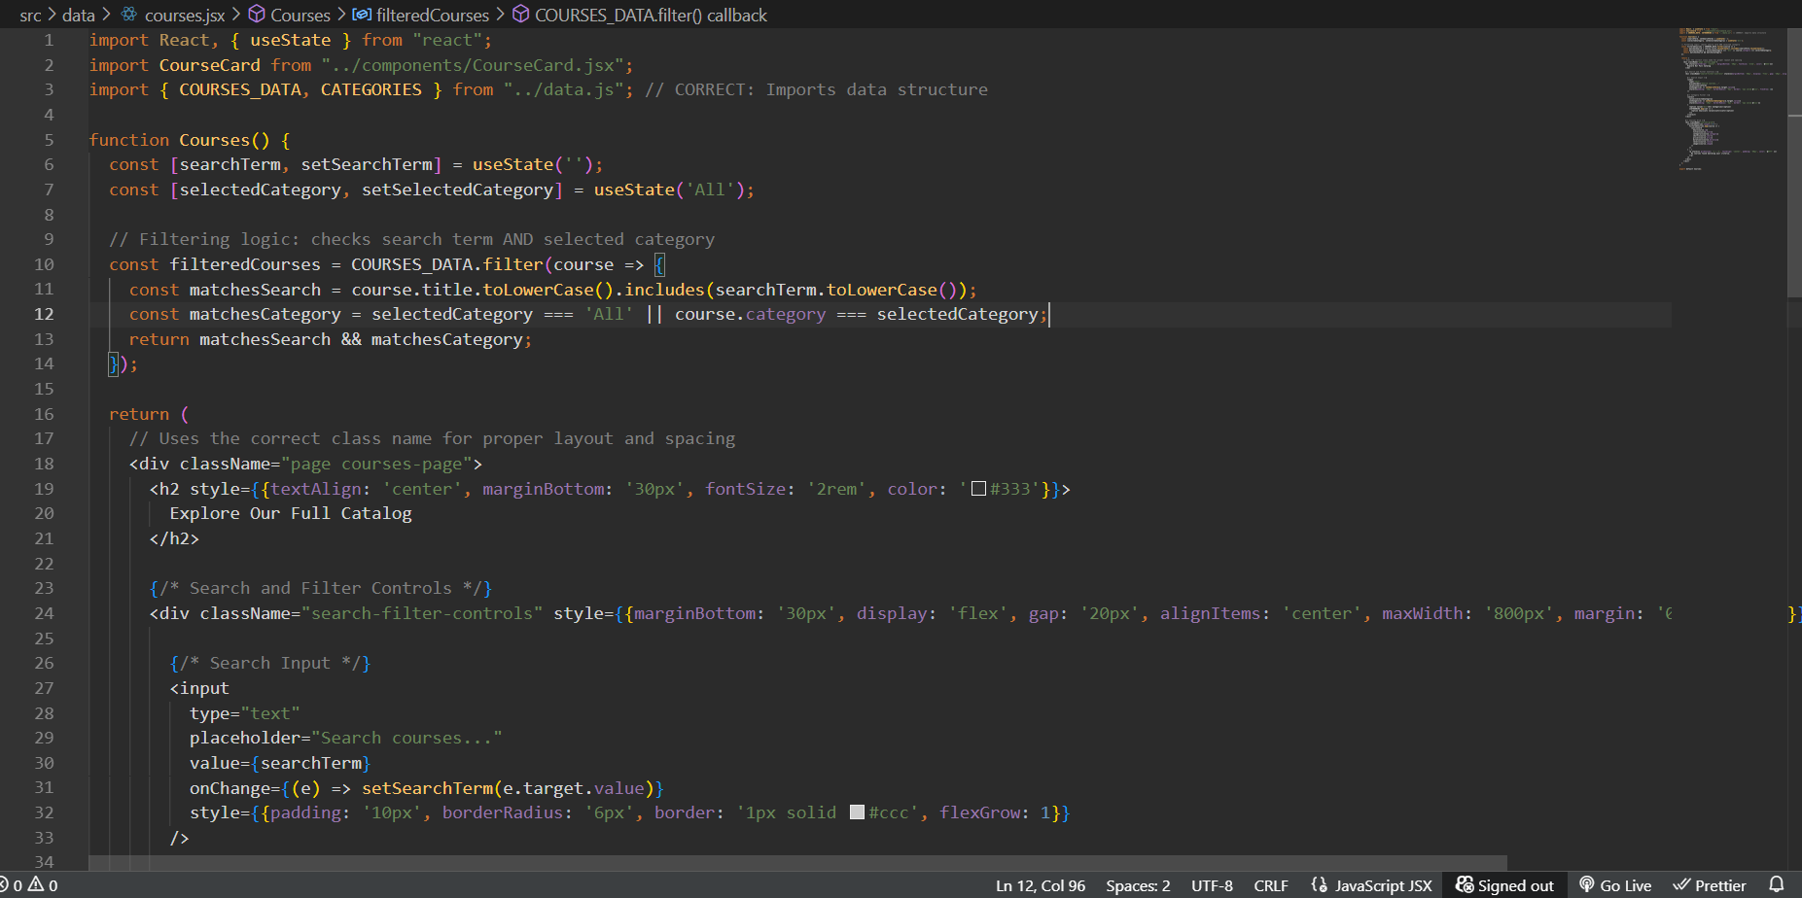
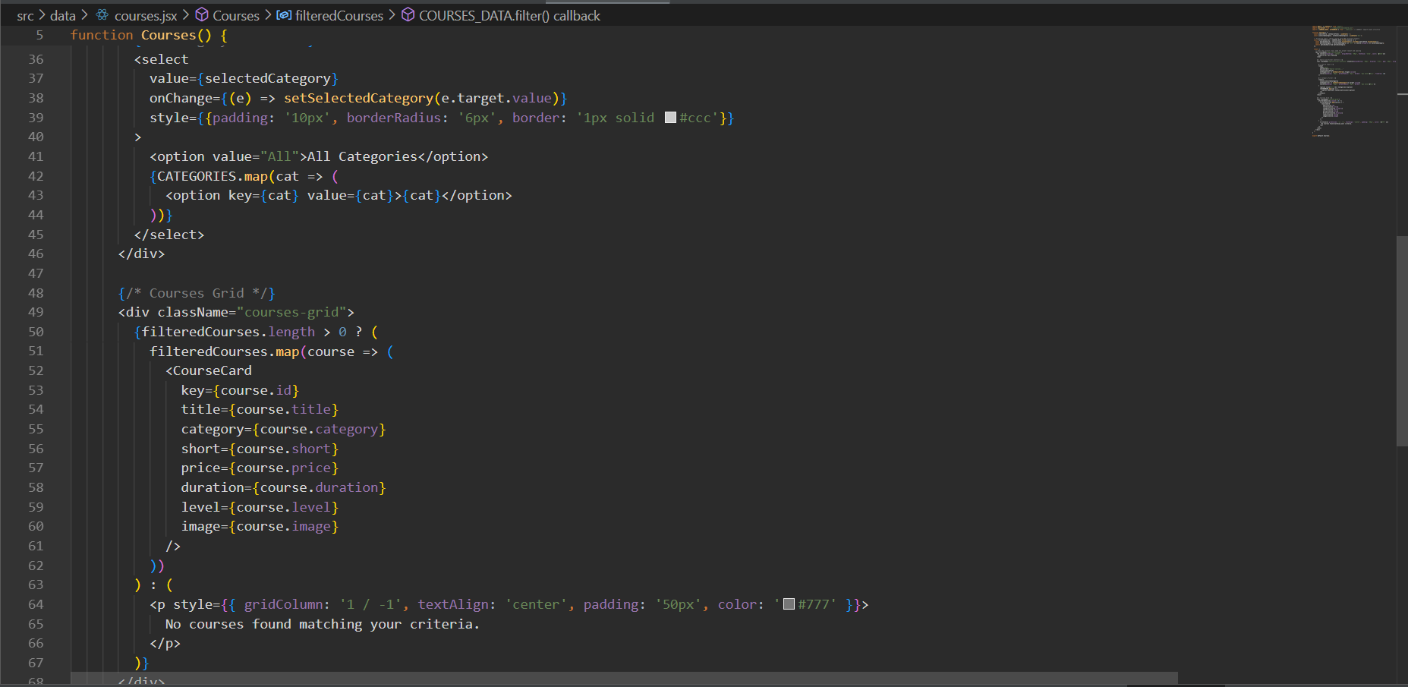
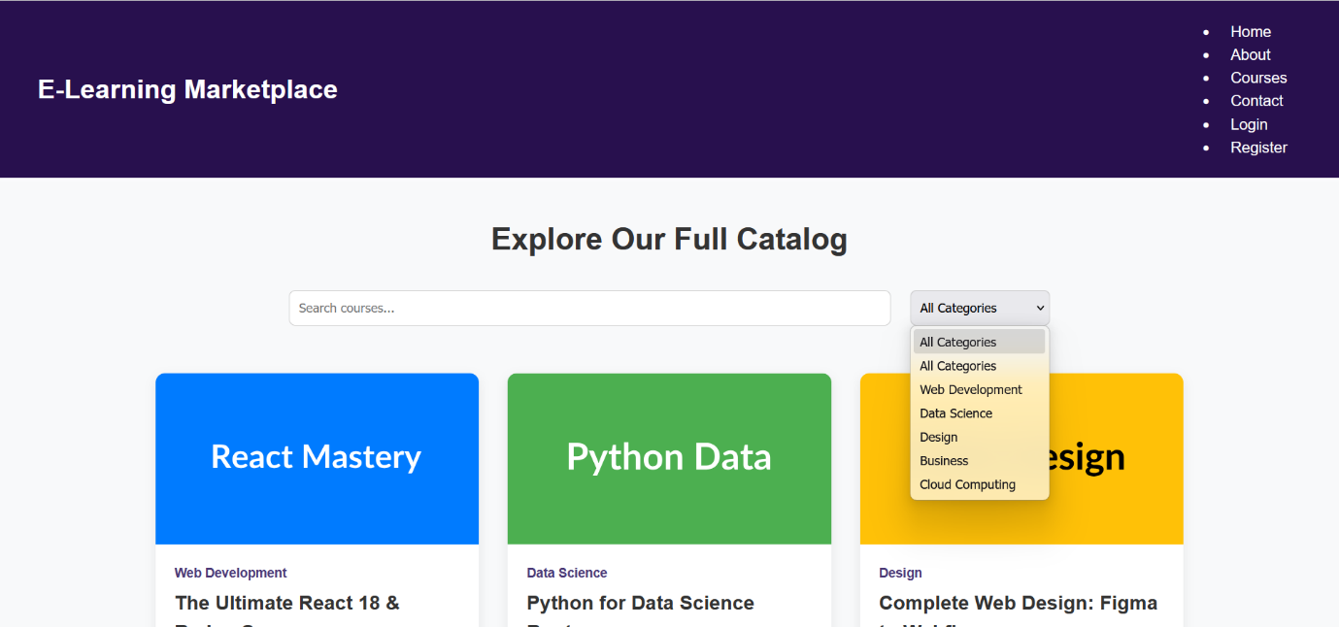

Part 5 – Checkout / Confirmation Page (Course Summary & Enrollment Review)
Aim:
To develop a Checkout or Confirmation Page in the Language Learning Website that summarizes the user’s selected courses, lessons, or subscription plans. The page allows learners to review their selections before confirming enrollment or proceeding to payment. This ensures that users verify all chosen courses and learning preferences, improving accuracy and enhancing the user experience during checkout.

Theory:
In e-learning platforms, a Checkout Page acts as the final stage before a user confirms enrollment or subscription. Within the Language Learning Website, this module functions as a Course Summary and Confirmation Page — displaying all selected courses, course levels, and payment details in one place for final review.
This page helps users ensure that they have chosen the right courses, modules, or learning packages before confirming their registration. Accuracy and transparency at this stage are essential, as they prevent user confusion or accidental selections. It represents the final confirmation step in the flow:
Home → Browse Courses → Add to Cart → Review & Checkout → Confirmation
From a technical perspective, this module uses ReactJS to dynamically fetch and display data stored in state or localStorage (previously added through the Cart Page). It demonstrates component communication and data persistence across different sections of the website — an essential skill in modern web development.
The Checkout / Confirmation Page includes:
- Course or Lesson Name
- Price or Subscription Type
- Duration (e.g., 4 Weeks / 8 Weeks)
- Level (Beginner / Intermediate / Advanced)
- Instructor Name
- Total Amount
- Action Buttons (Confirm / Edit / Go Back)
ReactJS makes it possible to display this information dynamically through:
- useEffect() for fetching data from localStorage or cart state.
- map() function to render each selected course as a summary card.
- Conditional rendering to handle empty-cart situations.
- onClick event handlers for “Confirm” or “Edit Cart” actions.
By integrating state management and localStorage synchronization, the page ensures that course data persists across navigation — avoiding data loss on reload and creating a smooth, app-like user experience. This kind of dynamic rendering is what makes Single Page Applications (SPAs) efficient and user-friendly.
From a UI/UX design perspective, the Checkout Page should be clean, clear, and professional. Using consistent color themes (such as purple, white, and black) maintains the website’s learning identity. Courses can be displayed in responsive cards or tables with pricing and details grouped neatly. Buttons like “Go Back” and “Confirm Enrollment” improve navigation and guide users through the process intuitively.
The purpose of this module is not only functional but psychological — it builds trust and confidence. When users see their course summary presented clearly and accurately, they feel secure about their enrollment decisions. This sense of confirmation is key to professional user experience design, even in a student-level project.
Looking forward, this component can serve as a foundation for more advanced features such as:
- Integrating a payment gateway (e.g., Razorpay, PayPal).
- Generating a confirmation receipt or PDF summary.
- Sending email or SMS confirmations.
- Adding discount codes or offers dynamically.
Thus, the Checkout / Confirmation Page connects all modules together — turning a static learning site into a dynamic, user-centered application.

Conclusion:
The Checkout / Confirmation Page in the Language Learning Website effectively demonstrates how ReactJS can be used to create a smooth and reliable data verification interface. It showcases how different components — such as course listings, cart items, and user selections — can interact seamlessly through shared state and localStorage.
From a technical standpoint, this module strengthens understanding of:
- Component reusability
- Data retrieval and persistence
- Conditional rendering
- Event-driven user flow control
From a user perspective, it enhances trust and satisfaction by providing a clear summary before confirmation. This ensures accuracy, reduces errors, and improves the overall learning experience.
Overall, this module represents the final stage of the learner journey — turning browsing into commitment. It blends interactivity, clarity, and professionalism, embodying the purpose of the Language Learning Website: to make digital education more structured, transparent, and user-friendly.

Code:
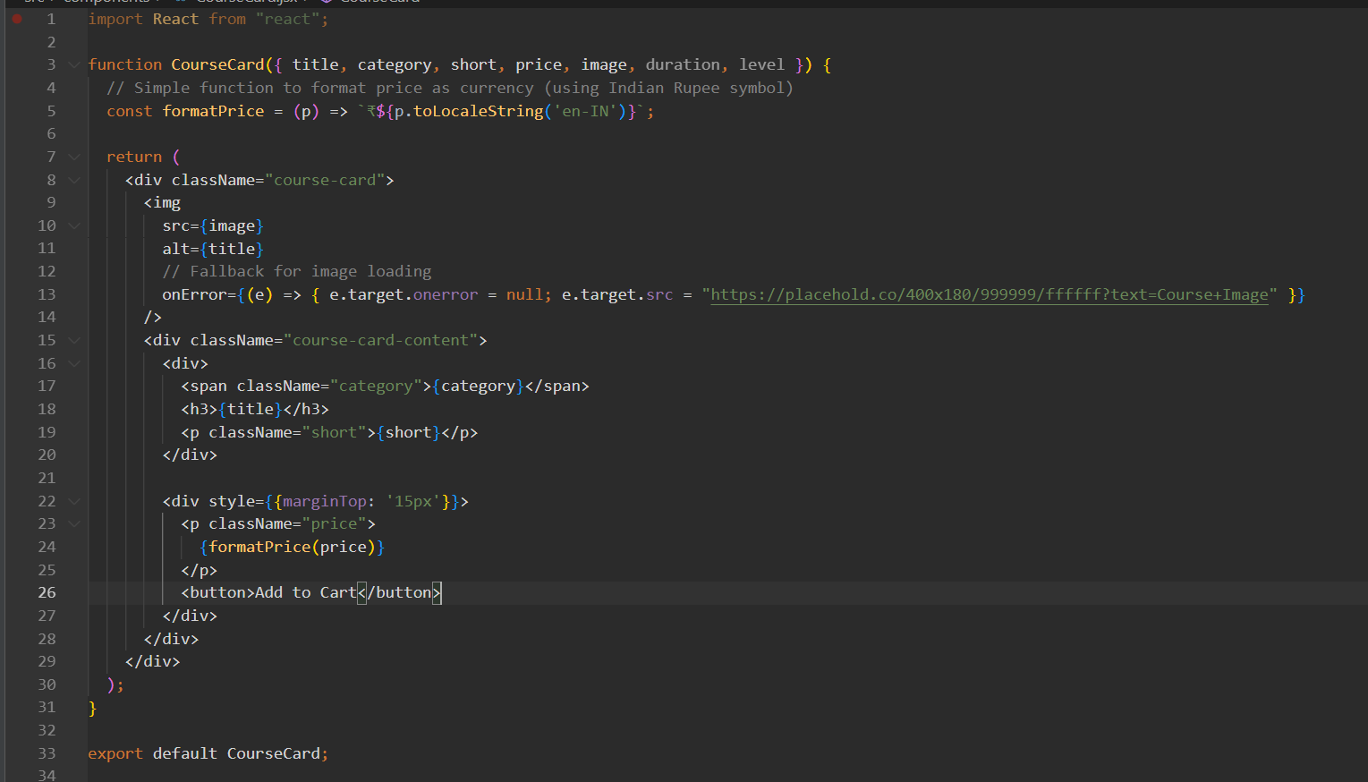
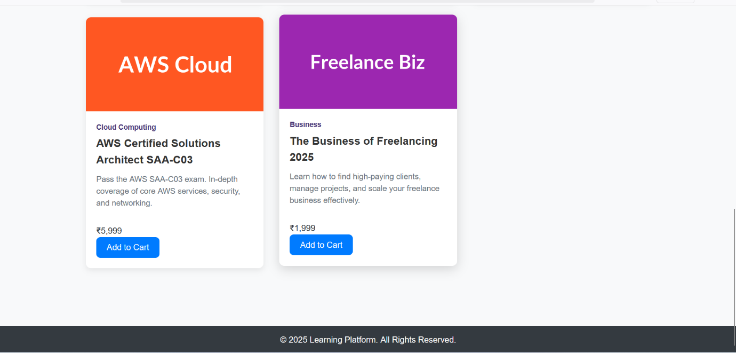

Part 6 – Checkout Page (with Course Progress Tracker)
Aim:
To design and implement a Checkout Page in the Language Learning Website using ReactJS, allowing users to review their selected courses, check their current learning progress, view total costs, enter billing or enrollment details, and confirm their course registration — all while ensuring smooth data handling via local storage and a responsive, user-friendly interface.

Theory:
In e-learning applications, the Checkout Page serves as the final but most crucial step before a learner officially enrolls in a course or language program. It provides users with a detailed review of their selected courses and helps them verify whether they are ready to proceed based on their current progress or pending modules.
In this enhanced version, the Checkout Page not only displays the courses added to the cart but also shows current learning progress — how much of each course the user has already completed. This feature promotes responsible learning behavior, encouraging users to finish existing lessons before purchasing new ones.
For example:
If a user has already completed 60% of the French Beginner course and adds French Intermediate to the cart, the checkout screen might display:
“You’ve completed 60% of the Beginner course. Are you ready to start the Intermediate level?”
This feedback helps learners plan their progress strategically and prevents them from overwhelming themselves with too many courses at once.

Technical Implementation:
In ReactJS, this feature is implemented by storing both cart data (selected courses) and progress data (learning completion percentage) in localStorage or using Context API. When the Checkout Page loads, both datasets are retrieved and compared — allowing the user to see their progress and course readiness in real-time.
React Hooks such as useState and useEffect are used to manage and display this dynamic information:
- useEffect() loads user progress and cart items from localStorage when the component mounts.
- useState() stores the retrieved data and updates the UI instantly whenever a user modifies their cart or enrollment details.
- Conditional rendering ensures that progress details are only shown for existing courses, keeping the layout clean and relevant.
The checkout interface is divided into two main sections:
- Course Summary Panel – Displays course name, price, level (Beginner / Intermediate / Advanced), and completion percentage.
- Enrollment Form – Collects user information such as name, email, and payment or enrollment details.
A Total Cost field is automatically calculated using JavaScript’s reduce() function, ensuring accurate and dynamic pricing even if courses are added or removed. The “Confirm Enrollment” button triggers a success state and optionally clears the cart after completion.

User Interface & Experience Design:
From a UI/UX perspective, the Checkout Page in the Language Learning Website focuses on clarity and motivation.
- The use of progress bars (e.g., “You’ve completed 70%”) visually communicates learning achievements.
- The interface uses a clean purple, white, and black color palette for a professional, academic aesthetic.
- A responsive grid layout ensures that the page looks equally appealing on mobile and desktop devices.
- Action buttons like “Go Back”, “Edit Cart”, and “Confirm Enrollment” improve user navigation and control.
This design encourages students to reflect on their progress, celebrate achievements, and make thoughtful course decisions before final checkout.

Code Overview (Conceptual):
useEffect(() => {
const storedCart = JSON.parse(localStorage.getItem("cart")) || [];
const storedProgress = JSON.parse(localStorage.getItem("progress")) || {};
setCart(storedCart);
setProgress(storedProgress);
}, []);

const totalCost = cart.reduce((sum, course) => sum + course.price, 0);
Explanation:
- The code retrieves cart and progress data from localStorage.
- The total cost is dynamically calculated using the reduce() function.
- React re-renders the component automatically whenever cart data changes.

Conclusion:
The Checkout Page with Course Progress Tracking transforms the Language Learning Website into a more intelligent and learner-centered platform. It bridges the gap between course enrollment and personal progress awareness, ensuring users make informed decisions before joining new lessons.
By integrating React Hooks, localStorage, and dynamic rendering, this module achieves both technical robustness and user engagement. Learners gain a clear view of their academic journey — what they’ve achieved so far and what comes next.
This implementation highlights how ReactJS can be used not just for functional interfaces but also for educational empowerment. It promotes responsible learning, transparency, and motivation — turning a simple checkout page into a personal progress assistant.
In conclusion, this module showcases the perfect blend of ReactJS interactivity, modern design principles, and educational usability, contributing to a more personalized, effective, and engaging learning experience for every user.

Part 7 – User Profile Page
Aim:
To design and implement a User Profile Page in the Learning Website using ReactJS, where users can view and update their account details, track enrolled courses, view learning progress, and manage saved preferences — ensuring personalized and persistent data management using local storage.

Theory:
The User Profile Page plays a crucial role in enhancing personalization and user experience in a learning platform. It serves as a central dashboard where learners can manage their personal information, view enrolled courses, monitor their progress, and track their activity within the platform.
In the Learning Website, the profile page is designed to provide a seamless and interactive experience. It allows users to easily edit their details (like name, email, and course preferences), view saved courses or lessons, and check progress summaries — all in one organized interface.
From a technical perspective, the User Profile Page is implemented as an independent React component that interacts with local storage or a global state for data persistence. Even if the website is reloaded, the user’s profile data remains saved, ensuring continuity between sessions.

Core Concepts Used:
- State Management:
React’s useState hook is used to handle editable user details such as name, email, password, and selected courses.
- Data Persistence:
User data is stored and retrieved from localStorage, allowing the website to remember user preferences and progress after logout or refresh.
- Dynamic Rendering:
Profile data updates automatically using React’s virtual DOM, ensuring instant reflection of changes made by the user.
- Form Handling:
Controlled input components are used to manage updates to user data securely and efficiently, enabling real-time validation.
- UX and Accessibility:
The profile interface emphasizes a simple, readable, and responsive layout with high accessibility standards to suit users across devices.

Profile Page Features:
- User Information Card:
Displays personal details like name, email, and profile picture.
- Edit Profile Section:
Allows users to modify information such as name, password, and learning interests, and save changes instantly.
- Enrolled Courses & Progress Tracker:
Shows a list of enrolled courses along with completion percentages and progress bars.
- Saved Lessons or Wishlist:
Displays bookmarked lessons or favorite courses for easy access.
- Logout / Settings Options:
Enables users to log out or adjust privacy and theme preferences.

Profile Page Logic in ReactJS:
- User edits the input fields (name, email, password, etc.)
- Data updates dynamically in the component state using useState.
- On clicking “Save Changes”, the updated data is stored in localStorage.
- When the user revisits the site, the data is fetched using useEffect() and displayed automatically.

Design and Aesthetics:
The profile page uses Flexbox or CSS Grid for layout organization and responsiveness. The consistent purple, white, and black color scheme aligns with the website’s overall branding, ensuring visual harmony and a professional look.
Profile cards and buttons (like Edit, Save, and Logout) use rounded corners and smooth hover effects to enhance usability. The overall layout prioritizes clarity and minimalism, allowing learners to focus on their progress.

Importance in Learning Platforms:
- Encourages personalized learning journeys by storing user preferences and progress.
- Improves user trust by showing a consistent and professional interface.
- Enhances motivation by visually tracking achievements and learning goals.
- Acts as a central hub connecting other modules like Courses, Cart, and Checkout.

Conclusion:
The User Profile Page significantly enhances personalization and interactivity within the Learning Website. Using ReactJS features such as state management, controlled components, and local storage, it allows users to manage personal details, track enrolled courses, and monitor learning progress effectively.
By giving learners control over their information and preferences, the profile page fosters a sense of ownership and engagement — crucial elements for an educational platform.
The responsive design ensures accessibility across devices, making it easy for users to learn anytime, anywhere.
Overall, the User Profile Page not only strengthens the functionality of the Learning Website but also contributes to a more connected, user-focused, and motivating learning experience.

Code:
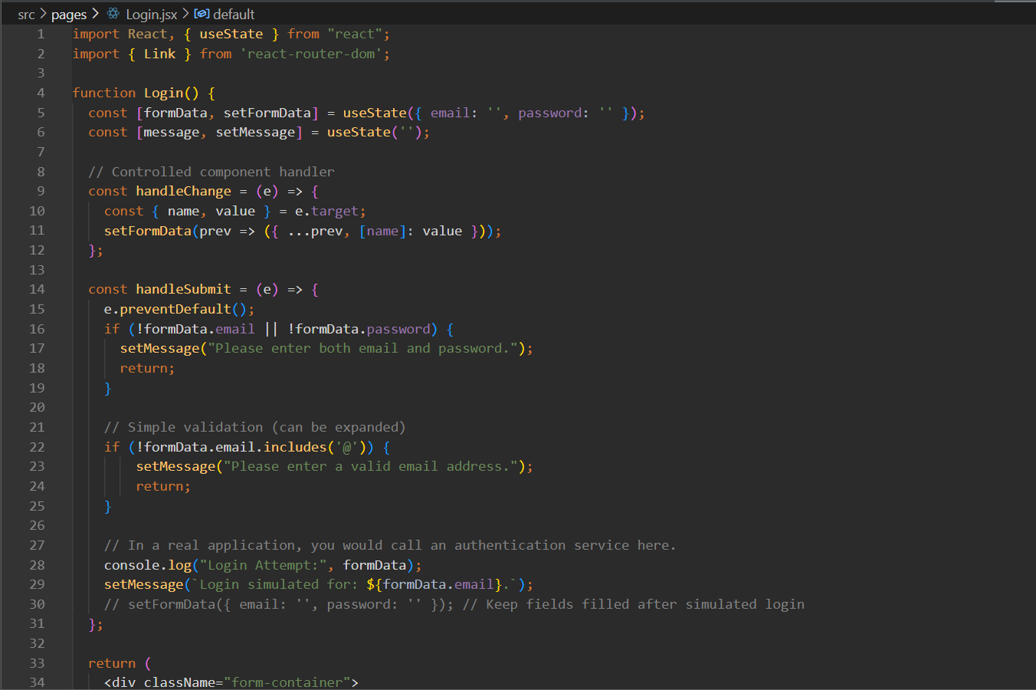
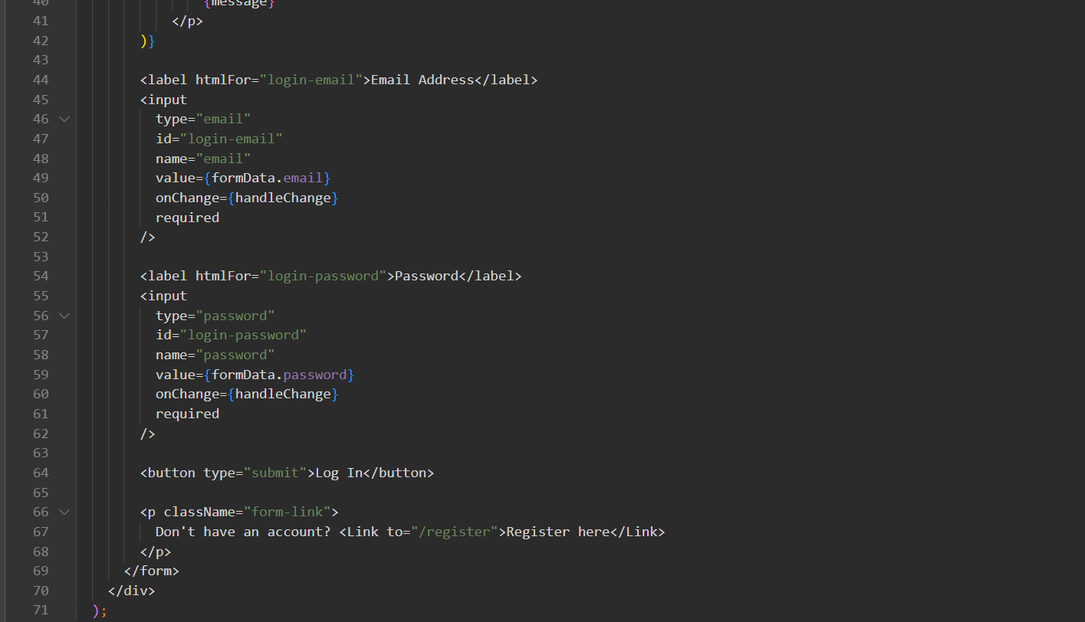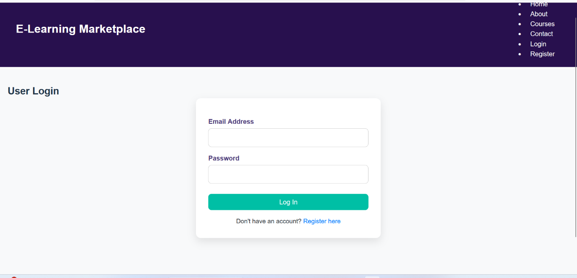

Part 8 – State Management with Context API / Redux
Aim:
To implement an efficient state management system using React Context API that allows seamless sharing of data — such as selected courses, cart items, user details, and progress updates — across different components (Home, Courses, Cart, Checkout, and Profile) of the Learning Website.
This ensures synchronized data flow and consistent updates throughout the application without repetitive prop passing or redundant state duplication.

Theory:
In a growing ReactJS application like a Learning Platform, managing data efficiently is essential to ensure consistency between pages. When multiple components need access to the same data (for example, user details or selected courses), handling this through traditional prop passing becomes complex and inefficient.
To solve this challenge, React Context API provides a simple and powerful way to manage global state. It allows data to be stored and accessed by any component in the hierarchy without manually passing props through multiple layers (a process known as prop drilling).
In the Learning Website, the Context API can be used to manage shared data such as:
- 🎓 Selected Courses: Courses that a user has added to their learning list or cart.
- 🛒 Cart Items: Courses selected for enrollment or purchase.
- 👤 User Profile Data: Name, email, and preferences stored across sessions.
- 📈 Learning Progress: Completion percentage or time spent on each course.
- 💬 Saved Notes or Bookmarks: Lessons or resources marked by the learner.
The Context Provider wraps around the root of the app (in App.js), allowing all pages like Home, Courses, Cart, Checkout, and Profile to access and update the same global data.
For example:
- If a user adds a course to the cart on the Courses Page, it instantly reflects in the Cart and Checkout pages without reloading.
- If a user updates their name or preferences in the Profile Page, those details update everywhere in real-time.

Advantages of Using Context API:
- Global Accessibility:
Data can be accessed from any component without prop drilling.
- Consistency:
Ensures the same information (like selected courses or user data) is reflected across multiple pages.
- Performance Efficiency:
Reduces unnecessary re-renders by updating only the components that need the changed data.
- Ease of Maintenance:
All shared data logic is centralized, making the app more organized and scalable.
- Local Storage Synchronization:
The data remains stored even after the browser refreshes, ensuring that the user’s progress, selected courses, and preferences persist across sessions.

Technical Implementation (Overview):
- Context Creation:
- import React, { createContext, useState } from 'react';
- export const LearningContext = createContext();
- Provider Component:
Wrap the app in a LearningProvider that manages the global state.
- export const LearningProvider = ({ children }) => {
- const [cart, setCart] = useState([]);
- const [user, setUser] = useState({});
- const [progress, setProgress] = useState({});
- return (
- <LearningContext.Provider value={{ cart, setCart, user, setUser, progress, setProgress }}>
- {children}
- </LearningContext.Provider>
- );
- };
- Usage Example:
Any component can access or update this data using useContext(LearningContext).

Redux (Alternative for Larger Apps):
While Context API is sufficient for small to medium projects like this Learning Website, large-scale learning management systems may prefer Redux.
Redux offers a centralized store, actions, and reducers that make state transitions predictable and easier to debug, especially in apps with complex interactions like live classes, payments, or course recommendations.
However, for your current project’s size and complexity, Context API is lightweight, easier to implement, and provides all the necessary functionality for efficient state sharing.

Real-world Application in the Learning Website:
Action | Context API Result
Add a course to cart | Instantly updates all pages (Cart, Checkout)
Update profile name | Automatically reflects in header and profile
Complete a lesson | Progress percentage updates globally
Logout | Clears global state and resets UI
This synchronized interaction provides a seamless learning experience, where every action feels instant and consistent across the entire site.

Conclusion:
The integration of React Context API in the Learning Website successfully establishes a centralized and efficient state management system.
By enabling smooth communication between components like Home, Courses, Cart, Profile, and Checkout, the website ensures a consistent and dynamic user experience without prop drilling.
This approach enhances app performance, improves maintainability, and allows users to interact with the website in a fluid, responsive way.
The Context API also supports future scalability — paving the way for more advanced features such as backend synchronization, progress analytics, or Redux integration if needed.
In conclusion, this module demonstrates how state management transforms a simple learning platform into a smart, data-driven education system, ensuring accuracy, interactivity, and a modern user experience for every learner.

Code:
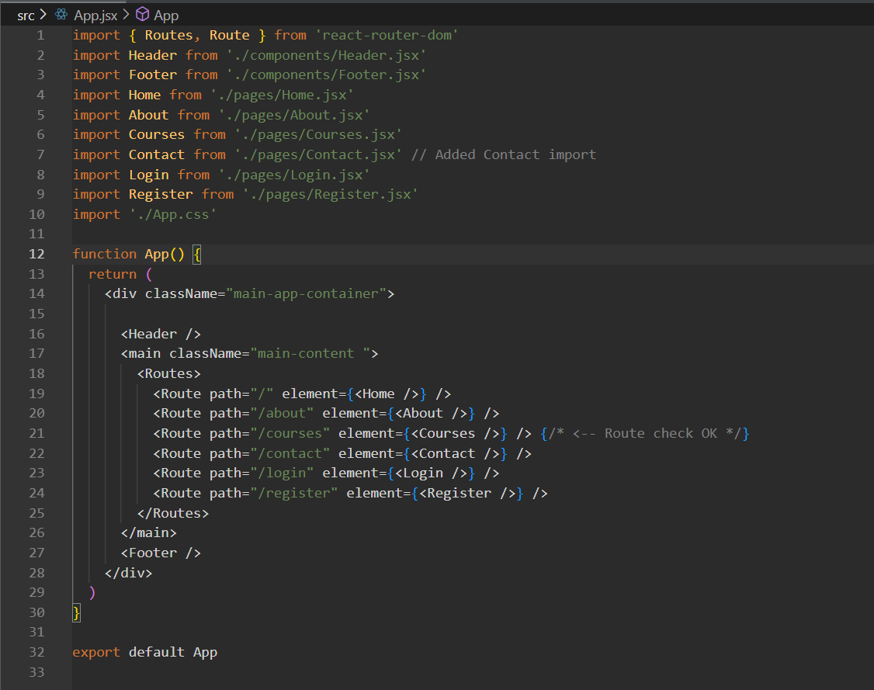
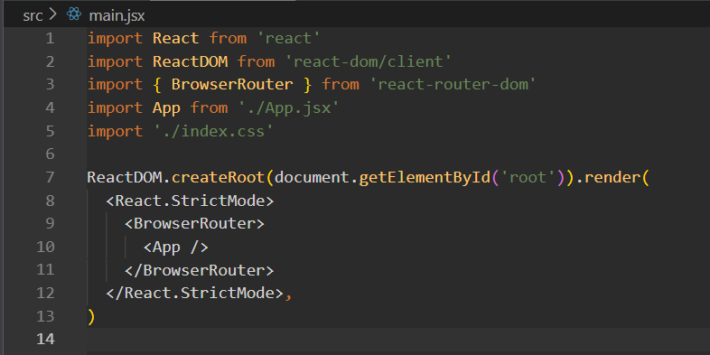

Part 9 – Responsive Design in React Learning Website
Aim:
To design and implement a responsive web interface for the Learning Website using ReactJS, ensuring that all pages — including Home, Courses, Categories, Cart, Profile, and Checkout — automatically adjust layout, components, and typography for optimal viewing on all screen sizes such as desktops, tablets, and mobile devices.
The goal is to achieve accessibility, usability, and visual consistency across devices without compromising performance or aesthetics.

Theory:
Responsive Web Design (RWD) is a fundamental principle in modern web development that ensures a website can adapt dynamically to various screen sizes and orientations.
For an educational platform like the Learning Website, responsiveness is critical since learners may access the website from laptops, tablets, or mobile phones. A well-designed responsive layout ensures that every user can easily explore courses, check their cart, and track progress without horizontal scrolling or layout distortion.
In this project, responsive design plays a vital role in enhancing the learning experience, usability, and accessibility. Whether a user is browsing a new course, reviewing their progress, or completing checkout, the interface automatically aligns and resizes content for comfortable viewing.

1. Role of CSS Flexbox and Grid in Responsive Design
Modern CSS layout systems — Flexbox and Grid — form the foundation of responsive design. They enable clean, flexible, and adaptive page layouts without relying heavily on floats or fixed dimensions.
a. CSS Flexbox (Flexible Box Layout):
Flexbox is ideal for one-dimensional layouts — arranging elements in a row or column.
In the Learning Website, Flexbox is used to align:
- The Navigation Bar (for spacing links like Home, Courses, Cart, Profile).
- The Course Cards Section (for dynamic alignment across screen sizes).
- The Footer (for centering copyright and quick links).
Flexbox properties like justify-content, align-items, and flex-wrap make the content automatically adjust to the available space.
Example:
On a large desktop, four course cards appear side by side, but on a mobile screen, they stack vertically for better readability.
.course-container {
display: flex;
flex-wrap: wrap;
justify-content: center;
gap: 20px;
}
.course-card {
flex: 1 1 250px;
margin: 10px;
}

b. CSS Grid Layout:
CSS Grid provides two-dimensional control (rows and columns), perfect for complex layouts like dashboards or course listings.
In the Learning Website, Grid is used for:
- Displaying course cards in structured rows and columns.
- Organizing the Profile Page with sections like user info, progress stats, and enrolled courses.
- Designing the Checkout Page with clear separation between the order summary and user form.
Example:
.course-grid {
display: grid;
grid-template-columns: repeat(auto-fit, minmax(250px, 1fr));
gap: 20px;
}
This ensures the layout automatically adapts from multiple columns on desktop to a single column on mobile.

2. Media Queries and Breakpoints
Media queries are a key part of responsive design, enabling different styles to apply at specific screen widths.
In the Learning Website, breakpoints are used to modify layouts for tablets and mobiles:
@media (max-width: 768px) {
.navbar {
flex-direction: column;
}
.course-card {
width: 90%;
margin: auto;
}
.footer {
text-align: center;
}
}
At smaller widths:
- The navbar collapses into a dropdown or vertical menu.
- Course cards expand to full width for better visibility.
- Buttons and text resize to maintain readability.

3. Implementation in ReactJS
React integrates perfectly with CSS responsiveness. Each component (Navbar, Home, Courses, Profile, Cart, Checkout) is styled using:
- Component-specific CSS files (e.g., Home.css, Courses.css), or
- CSS Modules / Styled Components for scoped and reusable styling.
Key responsive behaviors in the Learning Website:
- Navbar: On mobile, it converts into a hamburger-style dropdown.
- Home Section: Hero banner text and images resize automatically.
- Courses Page: Cards rearrange from 3-column to 1-column.
- Profile Page: Displays info cards stacked vertically on smaller screens.
- Checkout Page: The summary and form sections align vertically on mobiles for better accessibility.
This modular component-based approach ensures each section maintains responsiveness independently.

4. Benefits for an Educational Platform
For a Learning Website, responsive design enhances both usability and accessibility — making it easier for students to browse courses, track learning, and check out seamlessly on any device.
Key Benefits:
- Universal Accessibility: Learners can study from any device, anywhere.
- Improved User Experience: Clear typography, scalable visuals, and easy navigation.
- Consistent Design: Maintains brand style and color identity (Purple, White, and Black).
- Higher Engagement: Smooth interaction encourages users to explore more content.
- Performance Efficiency: One codebase adapts to all devices, reducing redundancy.
A responsive design is not just an aesthetic choice but a functional necessity — ensuring that your learning platform is inclusive, modern, and user-friendly.

Conclusion:
The implementation of Responsive Design in the Learning Website ensures a seamless and optimized user experience across all devices. By leveraging CSS Flexbox, Grid, and media queries, the layout adapts dynamically without breaking functionality or design integrity.
Each component — from the navbar to the checkout form — automatically aligns and scales based on screen size, maintaining accessibility and visual consistency.
The combination of ReactJS modular architecture and modern CSS layout systems allows for clean, maintainable, and professional web design.
In conclusion, responsiveness transforms the Learning Website from a static interface into a dynamic, device-friendly educational platform, enabling learners to enjoy smooth navigation, readability, and interactivity — anytime, anywhere.

Code:
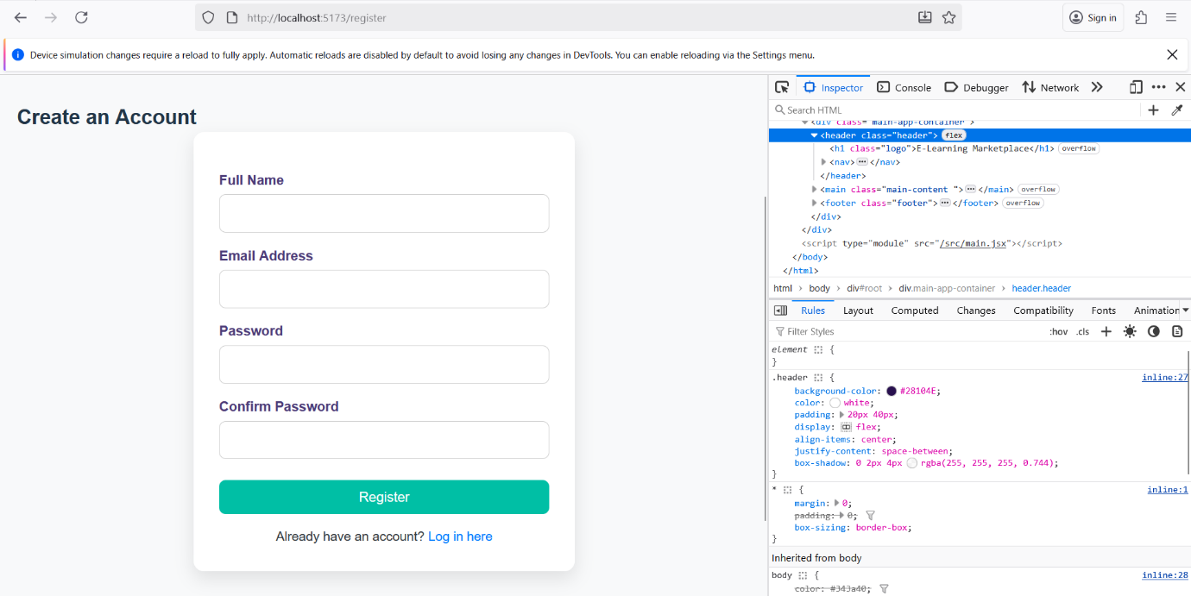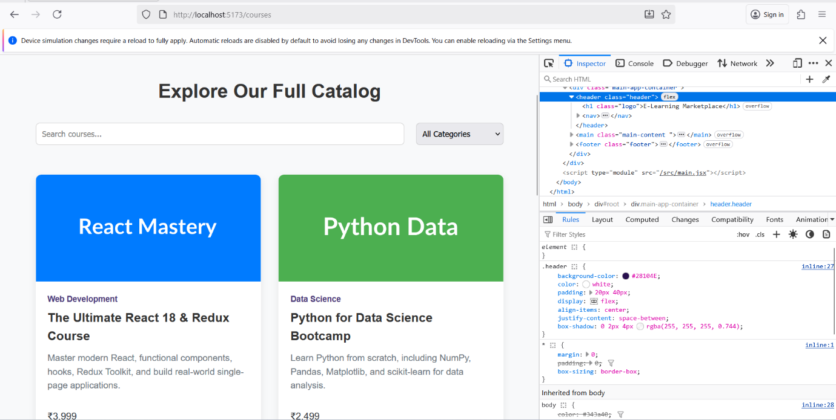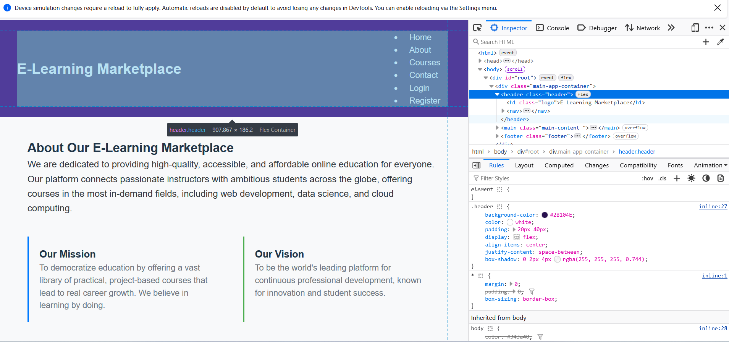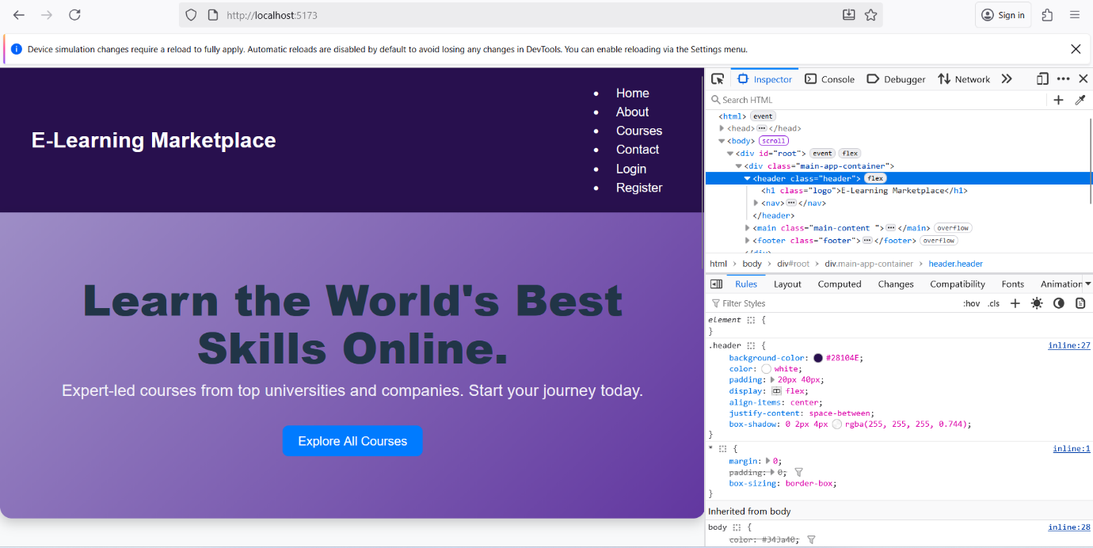

Assignment 1: Create a Static Homepage Layout Using Bootstrap
Aim:
To design a responsive homepage for the Learning Website using Bootstrap components such as containers, navigation bars, hero banners, and buttons. The homepage should effectively introduce the learning platform, highlight its core features like interactive courses, quizzes, progress tracking, and student-friendly design, while maintaining a visually appealing and mobile-friendly layout.

Theory:
A homepage serves as the first impression and central entry point of any web application. For an educational web app like the Learning Website, it must clearly convey its purpose — providing accessible, interactive, and organized learning content. It should help users easily navigate through sections like Courses, About, Contact, and Login, while maintaining simplicity and responsiveness.
Bootstrap, a powerful front-end CSS framework, helps developers quickly build responsive and consistent web layouts without writing custom CSS from scratch. Its grid system, predefined components, and utility classes make it ideal for creating structured educational websites that look good on all devices.

1. Bootstrap Containers and Grid System:
The container is the foundation of every Bootstrap layout. It ensures that the content remains properly aligned and adapts to various screen sizes — mobile, tablet, or desktop.
Inside the container, rows and columns divide the homepage into logical sections:
- A hero banner introducing the website.
- Feature highlights like "Learn Anytime, Anywhere" or "Track Your Progress."
- Call-to-action buttons such as Explore Courses or Join Now.
Bootstrap’s 12-column grid system ensures flexibility — for instance, three feature cards may appear side by side on a laptop but automatically stack vertically on a mobile device, maintaining readability and design consistency.

2. Hero Section (Jumbotron):
The Hero Section (modern replacement for Jumbotron) acts as the main visual highlight of the homepage.
For the Learning Website, this section can display:
“Empowering You to Learn and Grow — One Lesson at a Time!”
It can include:
- A short description of the platform (e.g., “Access free online courses, track your learning, and improve your skills.”)
- A large call-to-action button like “Start Learning Now.”
- A background image or subtle gradient matching the website’s color theme (e.g., purple and white).
This area immediately engages visitors and encourages them to explore further.

3. Responsive Design:
Bootstrap’s responsive utilities like .d-flex, .justify-content-center, .align-items-center, and .img-fluid help adjust content dynamically for all screen types. This ensures that whether a student accesses the website on a smartphone, tablet, or desktop, the interface remains clear, consistent, and easy to navigate.
For a learning platform, this responsiveness is essential, as students often switch between devices during their study sessions.

4. Buttons and Utility Classes:
Bootstrap buttons (.btn, .btn-primary, .btn-outline-light) enhance interactivity and guide users through key actions. For example:
- “Explore Courses” → Leads to the course listing page
- “Sign Up” → Opens registration
- “Contact Us” → Directs users to support
Using Bootstrap’s utility classes (p-3, m-2, text-center, etc.) helps maintain consistent spacing, alignment, and text formatting, making the homepage neat and modern.

5. Bootstrap Tables Overview:
Although not directly part of the homepage, Bootstrap tables play an important role in other sections of the learning website — for example, displaying enrolled courses, quiz scores, or progress reports.
Common Bootstrap table classes include:
- .table – Adds default table styling.
- .table-striped – Adds alternating row colors for readability.
- .table-bordered – Adds borders around cells, improving clarity.
- .table-hover – Highlights a row when hovered.
- .table-responsive – Makes tables scrollable on smaller screens, preventing layout issues.

Conclusion:
By using Bootstrap, we can design a clean, structured, and mobile-friendly homepage for the Learning Website without writing extensive CSS. The homepage effectively introduces the platform, highlights its learning features, and provides intuitive navigation.
This assignment establishes the foundation for the website’s user interface — ensuring a strong first impression, easy navigation, and responsive design that adapts to all users and devices.

Code:
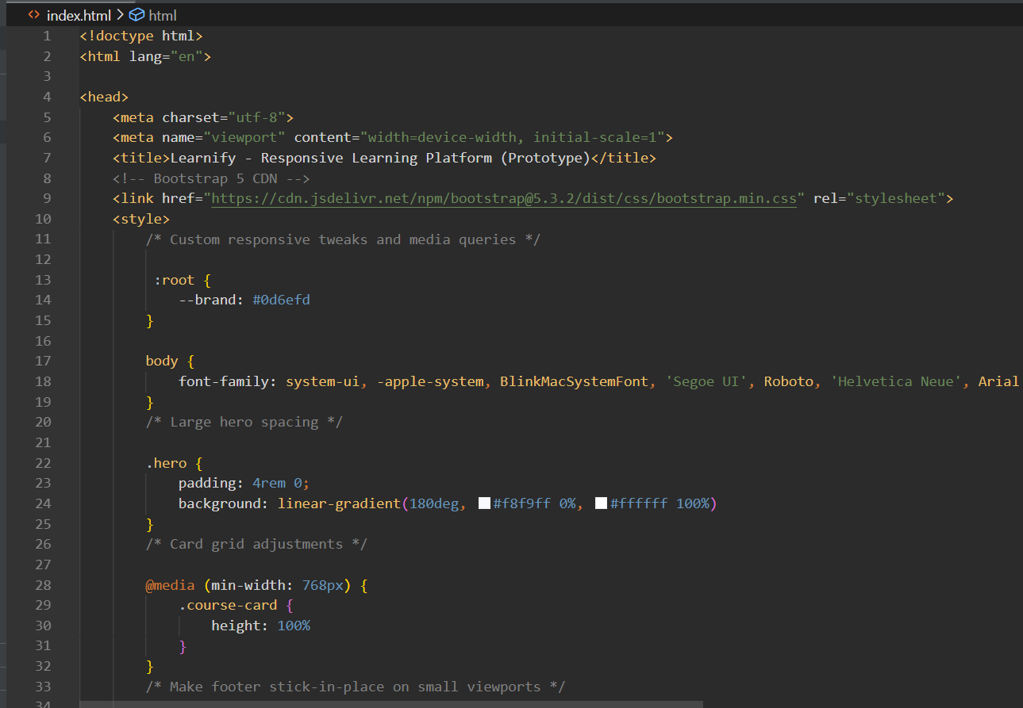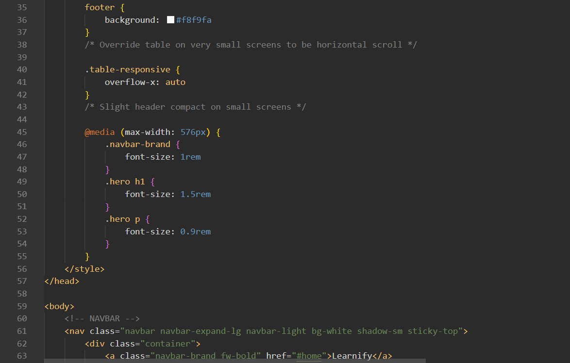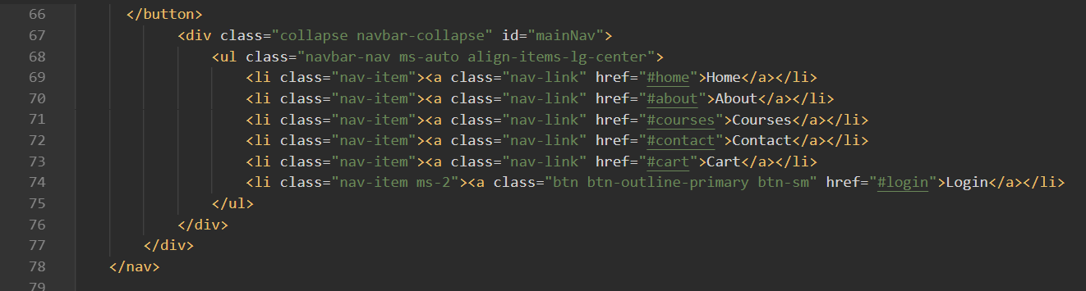
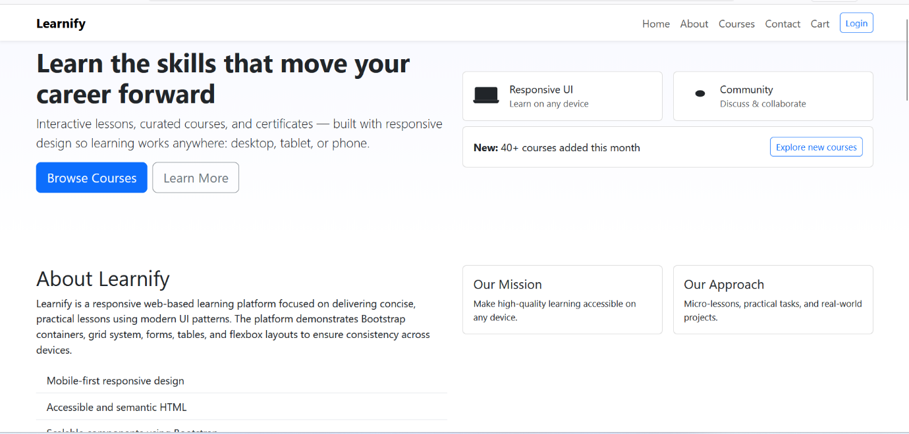

Assignment 2: Design a Grid-Based Information Page
Aim:
To develop a multi-column content layout using the Bootstrap Grid System for displaying structured information such as course cards, subject previews, or blog-style learning updates with proper alignment, spacing, and responsive behavior.

Theory:
The Bootstrap Grid System is a powerful layout mechanism built on Flexbox, allowing developers to design dynamic, responsive, and flexible web pages. It divides the page into 12 equal columns, which can be adjusted according to different screen sizes — ensuring that the layout looks perfect on mobile, tablet, and desktop devices.
In the Learning Website, the grid system can be used to organize and display course cards (like “Web Development,” “Python Programming,” or “Data Science”), learning resources, or featured blog posts in a neat, structured format. Each card can contain details such as course title, short description, instructor name, and difficulty level.

1. Components of the Bootstrap Grid System:
a) Container
The container serves as the main structural wrapper for all content. It provides alignment and horizontal padding to ensure a consistent design layout.
Bootstrap offers two main types of containers:
- .container – for fixed-width layouts that adapt at specific breakpoints.
- .container-fluid – for full-width layouts that span the entire viewport.
For the Learning Website, .container-fluid can be used to stretch the grid across the entire page, giving a clean and open layout.

b) Rows
A row (.row) is used to create a horizontal group of columns. Rows ensure that the columns inside them are properly aligned and that there is no unwanted spacing.
For example, in a course page, each row may contain three or four course cards depending on screen width.

c) Columns
Columns are the core building blocks of the grid system. They determine how content is distributed within a row.
Columns are defined using responsive classes like:
- .col- → for extra-small screens (mobiles)
- .col-sm- → for small screens (tablets)
- .col-md- → for medium screens (laptops)
- .col-lg- → for large screens (desktops)
2. Application in the Learning Website:
In this project, the grid system helps display multiple course or subject cards on a single page.
Each card can include:
- Course Name: e.g., “Introduction to HTML”
- Category: e.g., “Web Development”
- Description: A short summary of the course content
- Button: A “Learn More” or “Start Now” button for navigation
By using classes like .col-lg-3, .col-md-4, and .col-sm-6, the number of cards displayed per row automatically adjusts depending on the screen size, ensuring a smooth, responsive layout.
Conclusion:
Through this assignment, we successfully implemented a grid-based layout that organizes course information cards responsively. The use of Bootstrap’s grid system and card components makes the Learning Website’s interface both visually appealing and highly functional across all devices.
This structure can be easily reused for other sections such as student profiles, progress reports, or blog posts, ensuring scalability and consistency.
The Bootstrap Grid System plays a key role in creating responsive, user-friendly layouts for educational platforms. By combining rows, columns, and cards, the website achieves an intuitive design that adapts effortlessly to different screens, ensuring a smooth learning experience.
Overall, Bootstrap’s grid architecture enhances both functionality and aesthetics, making the Learning Website more engaging, professional, and accessible to users across all device types.
Code:
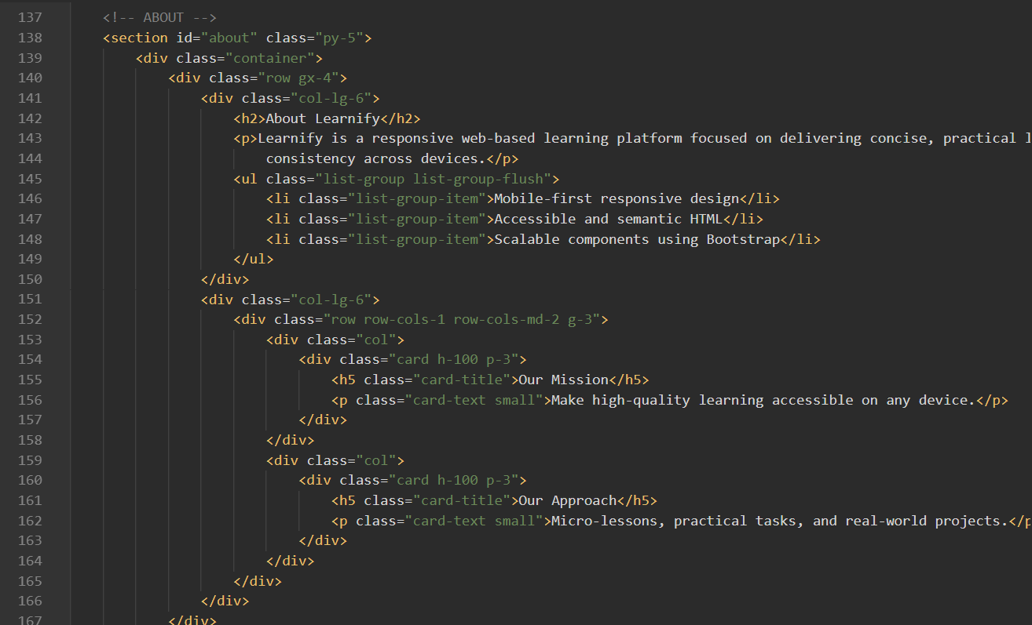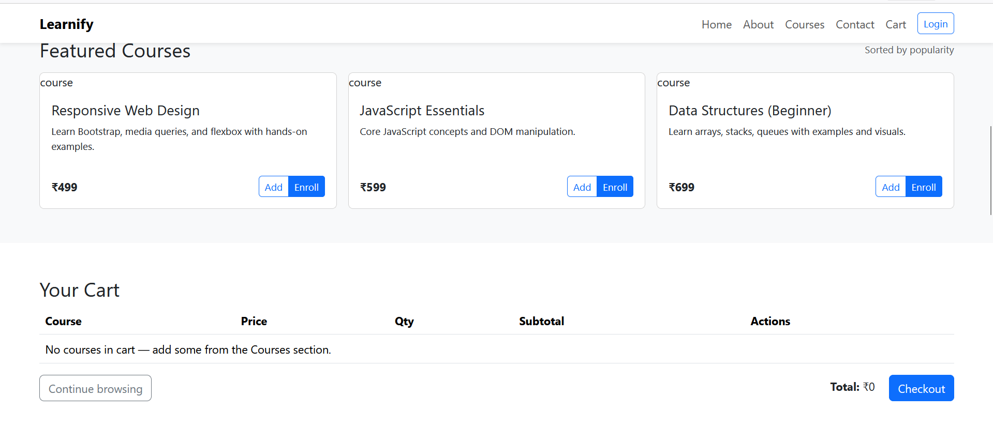

Assignment 3: Bootstrap Form and Table Integration
Aim:
To design and implement Bootstrap-based forms for the Registration, Login, and Feedback pages, and Bootstrap tables for displaying structured data such as enrolled courses, student progress, or performance reports.
The objective is to create a consistent, responsive, and user-friendly interface that enhances form handling and data presentation throughout the Learning Website.

Theory:
Forms and tables are among the most essential elements in any educational platform.
They facilitate data input (such as user registration or feedback collection) and data display (such as showing enrolled courses or performance statistics).
Bootstrap simplifies both through pre-styled, responsive, and accessible components that maintain visual consistency and usability across devices.

1. Bootstrap Forms:
Forms are used to collect information such as user details, login credentials, or feedback.
Bootstrap’s form components offer elegant styling and responsive alignment using a combination of grid layout and utility classes.
Commonly used classes include:
- .form-group → Groups form labels and controls with proper spacing.
- .form-control → Applies consistent styling to input fields like text boxes, dropdowns, and textareas.
- .form-row / .row → Aligns multiple input fields horizontally within the same row.
- Validation Classes (.is-valid, .is-invalid) → Provide real-time feedback for user input.
In the Learning Website, forms are used in sections like:
- Registration Page: To collect student name, email, and password.
- Login Page: For user authentication.
- Feedback Form: To gather course reviews and suggestions.
These forms enhance user interaction by ensuring inputs are well-organized, visually clean, and mobile-friendly.

2. Bootstrap Tables:
Tables are vital for presenting structured information clearly.
Bootstrap offers multiple table classes that improve readability, design aesthetics, and responsive behavior.
Key classes include:
- .table → Base class for all Bootstrap tables.
- .table-striped → Adds alternating row colors for easy scanning.
- .table-bordered → Displays cell borders for visual separation.
- .table-hover → Highlights rows when hovered over.
- .table-responsive → Enables horizontal scrolling on small screens.
In the Learning Website, tables can be used to display:
- List of enrolled courses with details like course name, duration, and progress.
- Student progress reports showing completed modules or marks.
- Feedback summary from various users.

3. Explanation:
- Bootstrap’s form classes ensure uniform spacing and alignment across devices.
- The grid layout system (.row, .col-md-*) helps place multiple form fields in a single row.
- Tables allow for organized display of learning data with improved readability and professional styling.
- Together, forms and tables ensure consistency, accessibility, and a seamless user experience across all pages.

Code:
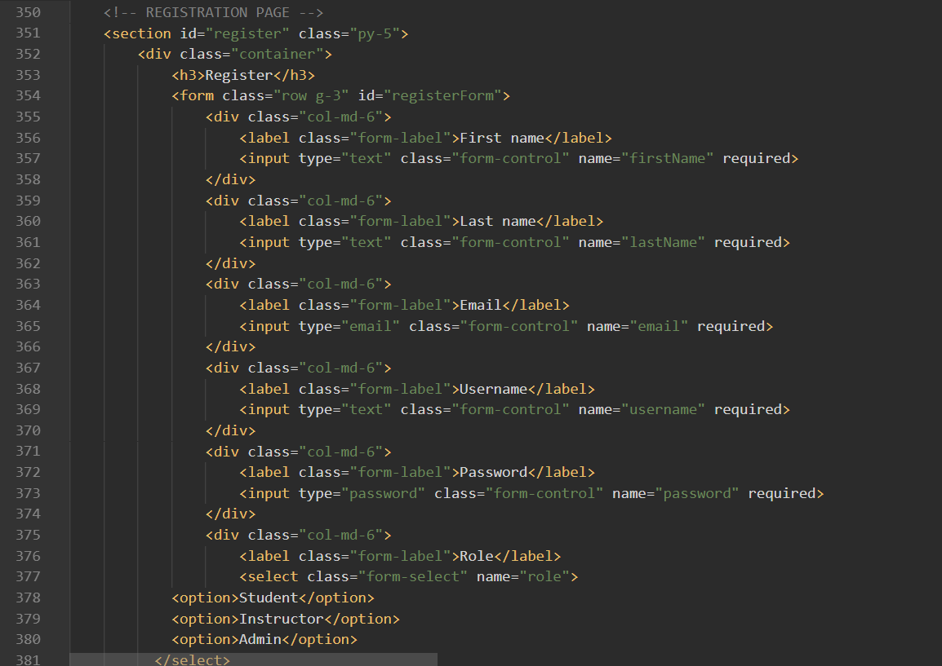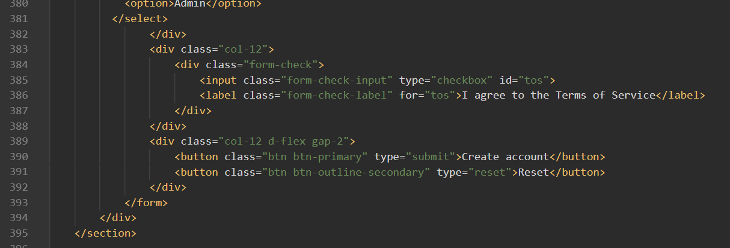
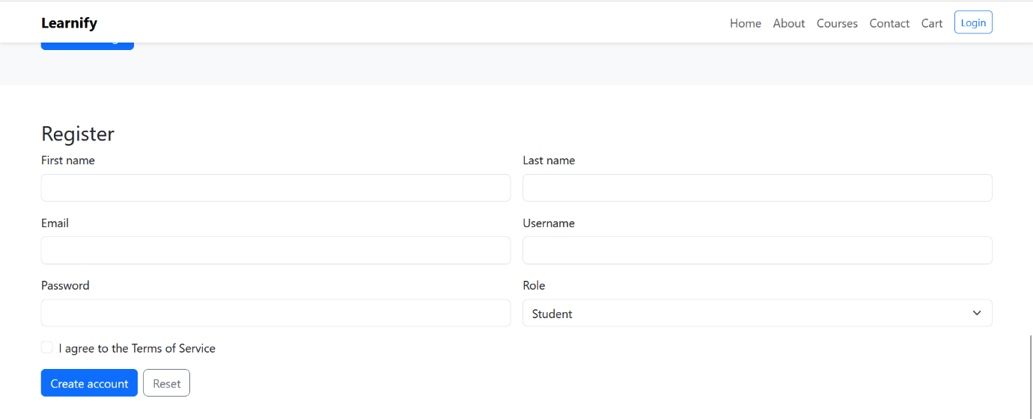
Assignment 4: Responsive Design Using Bootstrap Grid and Utilities
Aim:
To apply Bootstrap’s Grid System and Utility Classes across all pages of the Learning Website project to ensure a responsive, structured, and visually consistent design that adapts seamlessly across mobile, tablet, and desktop screens.

Theory:
Responsive design is a key principle of modern web development that ensures websites automatically adjust their layout and elements according to the user’s screen size and device type.
For a learning platform, responsiveness is essential so that students and teachers can easily access lessons, courses, and resources from any device — be it a mobile phone, tablet, or laptop.
Bootstrap provides a 12-column grid system and a rich set of utility classes that help developers create flexible, mobile-first, and responsive layouts with minimal CSS customization.

1. Bootstrap Grid System:
The Bootstrap Grid System is based on containers, rows, and columns that create responsive structures for web pages. It divides the page into 12 equal parts, allowing developers to align and organize content efficiently.
Key Concepts:
- Containers: Wrap page content for proper alignment and padding.
  - .container (fixed width) or .container-fluid (full width)
- Rows and Columns:
Rows contain columns, and each column’s width is defined using classes like:
  - .col- → Extra small devices
  - .col-sm- → Small devices (≥576px)
  - .col-md- → Medium devices (≥768px)
  - .col-lg- → Large devices (≥992px)
  - .col-xl- → Extra large devices (≥1200px)
2. Bootstrap Utility Classes:
Bootstrap includes numerous utility classes that allow developers to quickly style and position elements without writing custom CSS. They improve efficiency and maintain consistency across pages like Home, Courses, About, and Contact.
a. Flex Utilities:
Flexbox utilities make it easier to align and distribute content within containers.
- .d-flex → Defines a flex container.
- .justify-content-center → Centers items horizontally.
- .align-items-center → Centers items vertically.
- .flex-wrap → Allows elements to wrap to the next line.
b. Spacing Utilities:
Spacing utilities manage margins and padding effectively.
- Margins: m-* or mt-*, mb-*, ms-*, me-* (e.g., mt-4 = margin-top 1.5rem)
- Padding: p-*, px-*, py-* (e.g., p-3 = padding 1rem)
- Auto Margins: mx-auto centers block elements horizontally.
c. Text Utilities:
Typography enhances readability and draws attention to key content.
- .text-center → Centers text.
- .fw-bold → Makes text bold.
- .text-primary, .text-success, .text-danger → Adds color coding.
d. Display and Visibility Utilities:
Visibility classes help control what users see depending on their device.
- .d-none → Hides an element completely.
- .d-md-block → Displays an element only on medium and larger screens.
- .d-sm-inline-block → Displays an element on small screens.
Conclusion:
In this assignment, Bootstrap’s Grid System and Utility Classes were successfully implemented across the Learning Website project to make it fully responsive and consistent across all devices.
By combining Bootstrap’s flexible grid structure with alignment, spacing, and visibility utilities, the website provides a user-friendly interface that adjusts gracefully to any screen size.
Benefits achieved:
- Improved usability on mobile, tablet, and desktop.
- Reduced custom CSS through built-in utilities.
- Faster development and maintenance.
- A professional, cohesive visual design for all pages.
In conclusion, responsive design using Bootstrap ensures that the Learning Website remains accessible, visually appealing, and easy to navigate — helping learners focus on education, not layout issues.

Code:
